***Module – 02***

**What is Green Economy?**

A green economy is defined as low carbon, resource efficient and socially inclusive. The economic activities are such that it allow reduced carbon emissions and pollution, enhanced energy and resource efficiency, and prevention of the loss of biodiversity and ecosystem services. It aims to improve production processes and consumption practices to reduce resource consumption, waste generation and emissions through its life cycle. The Green Economy provides a macro-economic approach to sustainable economic growth with a central focus on investments, employment and skills.

**Approach towards Green Economy**

1. Development and creation of policy and legislations, strategies at regional and national levels
2. Development of tools and techniques to assess the environmental impacts and social standards.
3. Implementation of the green policies and low carbon techniques for SPC (Sustainable production and Consumption)
4. Provisions of financing mechanisms for transformations and technology productions
5. Private and public sector collaborations in building and development of technologies and infrastructure for the green economy
6. Creation of awareness to all the stakeholders on the impacts of sustainable and green economy
7. Provision of training and capacity building to bridge the gap in green engineering knowledge
8. Application and establishment of research and development centres for lifelong learning and emerging technologies for green and sustainable engineering

**Advantages of Green Economy**

1. Reduction in production costs with responsible use of resources.
2. Reduction in energy consumptions with improved technologies.
3. Reduction in waste production through reuse and recycling of the products.
4. Creation of new jobs as business grows through green economy.
5. Better and healthier lifestyle of citizens is possible through green/ low carbon economy.
6. Increased or improved product durability and efficiency
7. The green economy will lead to overall sustainability of the planet.

**Challenges in Green Economy**

1. Unwillingness of business and governments for sustainable transformation
2. Implementing green and sustainable technologies needs huge capital investments.
3. Lack of awareness and impacts of unsustainable living on the economy and environment.
4. Implementation of such technologies in poverty-stricken regions is very difficult as it pose huge problems such as scarcity of resources and the substandard living of the people.

**Some examples of Green Economy**

1. United nations in 2009, provided below poverty residents in Peru with 1, 50,000 improved cookstoves, which ran on the solar power. The manufacturing, transportation, and installation of the cookstoves provided a huge job opportunity to the local residents. The programme resulted in energy efficiency, health, climate change and forest preservation while creating green jobs and sustaining livelihoods.
2. In Bangladesh more than 7 million people suffer from asthma attacks, use of MDI (Metered Dose Inhaler) i.e., use of aerosol sprayed into the nasal cavity cleared the asthma. Manufacturing of MDI caused CFC (Chlorofluorocarbons). The UN designed a technology with locally available resources to establish an industry to produce MDIs without any CFC emissions (use of ozone friendly alternatives). The MDIs was also made available to cheap prices.
3. In Uganda 85 per cent of the population was engaged in agriculture production, contributing to 42 per cent of the national GDP and 80 per cent of the exports earnings. The country practices organic farming and now has more than 2,00,000 ha of land under organic farming. The organic framing industry accounts for about 50 billion USD which presents a massive scope of globalization and revenue to the people. Also, organic farming completely removes the use of insecticides and pesticides.
4. Through its innovative approaches in urban planning, city management, and transport planning going back as far as the 1960s, Curitiba, Brazil has been able to grow in population from 361,000 (in 1960) to 1.828 million (in 2008), without experiencing typical drawbacks from congestion, pollution, and reduction of public space. The population density in the city has increased three-fold from 1970 to 2008. At the same time, the average green area per person increased from 1 km² to over 50 km².
5. Clean energy plans in Tunisia have saved the government $1.1 billion in energy bills, relative to initial investments of $200 million in clean energy infrastructure. Primary energy consumption from renewables, together with savings from energy efficiency, are expected to reach 20 per cent of total energy consumption.

**Eco Efficiency**

Eco-efficiency is a metric used to express how efficient economic activity is with regard to environmental impact. Eco-efficiencyis aims at reducing ecological damage to a minimum while at the same time maximizing efficiency. Specifically, maximizing the efficiency of a company’s production process. It is a management philosophy that many companies across the world have adopted. Eco-efficient companies use less water, material, and energy while recycling more.

Eco efficiency is measured through GDP of the country. GDP (Gross Domestic Product). It was developed for business models to determine their efficiency, now it can be broadly applied to economy of the country.

Environmental Cost and Economic output are known as Environmental Efficiency Indicators (EEI). EEI are tools to measure the efficiency and accuracy of the tools or techniques employed in the production. EEI is also a measure of outputs and gives an indicator of measures/ reforms to be undertaken in the process. EEI is also tool for decision making and policy measures.

**How to select an Eco Efficiency Indicator (EEI)**

1. **Guided by sustainability principles:** the sustainable engineering principles should be considered during the selection process. The indicators shall match the policy and regulations undertaken by the business. This will ensure that the correct information and data is available for the decision-making process.
2. **Taking the structure of the economy into account:** The indicators will largely depend on the economy and GDP of the country,
3. **Considering data availability and methodological issues:** Data availability for the measurement is an important criterion for selection of the indicator, when selecting the indicator care shall be taken to choose an indicator whose data and information set is available.
4. **Attuned/ attributed to the national sustainable development strategies**: The indicator shall be on similar lines with the sustainable strategies of the country.

**Some Examples of Eco Efficiency Indicator (EEI)**

1. **Water Intensity (m3/ GDP):** The intensity of water used for production/ consumption purpose and producing $ 1 for the GDP of the country.
2. **Energy Intensity (Joules/ GDP):** The intensity of energy both from renewable and non-renewable sources used for production/ consumption purpose and producing $ 1 for the GDP of the country.
3. **Material Intensity (DMI/GDP):** the intensity of raw materials used for production and consumption purpose and producing $ 1 for the GDP of the country.
4. **CO2 intensity (tons/ GDP):** Amount of Carbon-di-oxide generated by the country for every $1 GDP earned.
5. **Solid Waste Intensity (tons/GDP):** the tons of SW generated by the economy for every $1 GDP.

**Triple Bottom Line (TBL)**

All conventional business models have profit their base of reference/ measure. This profit alone approach will jeopardise the sustainability efforts of the economy. The alternative to this is the Triple Bottom Line approach, TBL maintains that companies should commit to focusing as much on social and environmental concerns as they do on profits. TBL theory posits that instead of one bottom line, there should be three: profit, people, and the planet.

1. **Profit:** In the context of the triple bottom line, profit can mean more than just how much money a company makes. A company must ensure it earns its income in ethical, fair manners. This includes soliciting business partners and vendors with which it aligns philanthropically. It also defines how a company develops its strategy or [financial operating plan](https://www.investopedia.com/terms/f/fop.asp). Ensuring the company is paying its fair share of local, state, or federal income taxes on a timely basis. Making sure the company is fostering economic wealth within its community by shopping local or utilizing small businesses. Committing to financially investing in the community through partnerships, developments,
2. **People:** In the context of triple bottom line, people refers to every individual that is in touch with a company. This includes but is not limited to:
   1. Employees. This means ensuring workers receive a fair wage in a safe environment that encourages professional development.
   2. Vendors. This means ensuring a diverse set of suppliers are used and prioritizing small businesses or minority-owners when appropriate.
   3. Customers. This means ensuring customers have fair access to products and their feedback regarding equity or safety are considered.
3. **Planet:** The largest deviation from purely financial reporting relates to reporting on environmental impacts. Often, a company must be forced between a lower-cost option or a more environmentally friendly alternative. A company may also choose between a less favourable alternative; for example, eco-friendly transit will likely be slower than aircraft.

**Measuring TBL**

1. **Profit:** Gross margin by geographical region to demonstrate consistent or equitable pricing across different demographic groups. Historical federal income tax payments, demonstrating its effective rate. Historical information (or lack of) late payments or penalties as a demonstration of financial responsibility.
2. **People:** Average employee payroll to demonstrate liveable wages that exceed local expectations for pay. Employment demographics such as proportion of employees in different age, race, sexual orientation, or religious groups. Vendor demographics such as businesses identifying as small businesses.
3. **Planet:** reductions in greenhouse gas emissions based on the difference between former processes and forecasted changes in new processes. Amount of waste generated in pounds; this may also include amount of recycled product over a period of time. Amount of energy consumption, adjusted for seasonality. Amount of fossil fuel consumption (may be adjusted for per-employee or per-sales lead should the company be growing).

**Advantages of TBL**

1. Aims to have positive impact on the world.
2. May boost employee retention as workers may appreciate favourable working conditions.
3. May result in greater external funds from investors seeking ESG investments.
4. May result in greater sales from customers seeking to support ESG companies.
5. May result in long-term efficiencies that reduce costs in the long run.

**Disadvantage of TBL**

1. May be more difficult to assess non-financial inputs or outputs.
2. Lack of comparability across impact groups (i.e. companies may need to choose one bottom line over the other)
3. May result in competing strategies, making it difficult to easily pivot from one plan to another.
4. Will likely increase the cost of operations due to needing to find alternative products or processes.

**Some Companies which use TBL Approach**

1. Ben and Jerry’s
2. LEGO
3. Starbucks
4. Mars
5. Nestle
6. Kodak
7. Sony
8. Toyota

**Guiding Principles of Sustainable Engineering**

1. Strive to ensure that material/energy inputs and outputs not hazardous

2. Waste minimization over waste management.

3. Design for easy separation and purification.

4. All components must be designed for maximum mass, energy, and temporal efficiency.

5. Avoid unnecessary consumption of mass/energy versus.

6. Use entropy and complexity as guidelines to decide end-of-cycle.

7. A product must not outlast its uses.

8. A product must not have unnecessary capabilities/capacities.

9. Minimize material diversity.

10. Product creation is only one part of the cycle.

11. Evaluate products based on life-cycle analysis.

12.Prioritize the use of renewable and readily available resources.

**Environmental Management Systems (EMS)**

An Environmental Management System (EMS) is a framework that helps an organization achieve its environmental goals through consistent review, evaluation, and improvement of its environmental performance. The assumption is that this consistent review and evaluation will identify opportunities for improving and implementing the environmental performance of the organization. The EMS itself does not dictate a level of environmental performance that must be achieved; each organization's EMS is tailored to its own individual objectives and targets.

**Elements of EMS**

1. Reviewing the organization's environmental goals.
2. Analysing its environmental impacts and compliance obligations (or legal and other requirements).
3. Setting environmental objectives and targets to reduce environmental impacts and conform with compliance obligations.
4. Establishing programs to meet these objectives and targets.
5. Monitoring and measuring progress in achieving the objectives.
6. Ensuring employees' environmental awareness and competence.
7. Reviewing progress of the EMS and achieving improvements.

**Need/ Benefits of EMS**

1. Effective EMS helps businesses reduce their environmental impact and improve the health and safety of both their employees and their communities.
2. EMS ensures that a company's activities do not violate environmental laws and regulations.
3. EMS helps companies improve operational efficiency and reduce costs due to the growing focus on energy efficiency and waste management.
4. Employees also have access to all environmental issues related to their work, helping them understand the importance of environmental awareness and personal behaviour.
5. The EMS helps for monitoring goals and tracking its progress.
6. EMS leads to continuous improvement and faster achievement of sustainability goals, contributing to a positive brand image.
7. Environmental management plays an increasingly important role in protecting our environment and public health.
8. EMS helps in addressing the environmental impacts of organization's activities and set goals, processes, and practices that improve your company's environmental and public health impacts.
9. EMS helps in better social image and brand building, this will lead to new clients and markets for business
10. EMS improves the employee morale and motivates them to work more efficiently.

**EMS (ISO 14001 – 2015)**



**1. Commitment and Policy -**Top management commits to environmental improvement and establishes the organization's environmental policy. The policy is the foundation of the EMS.

**2. Planning -**An organization first identifies environmental aspects of its operations. Environmental aspects are those items, such as air pollutants or hazardous waste, that can have negative impacts on people and/or the environment. An organization then determines which aspects are significant by choosing criteria considered most important by the organization.

**3. Implementation -**A organization follows through with the action plan using the necessary resources (human, financial, etc.). An important component is employee training and awareness for all employees (including interns, contractors, etc.). Other steps in the implementation stage include documentation, following operating procedures, and setting up internal and external communication lines.

**4. Evaluation -**A company monitors its operations to evaluate whether objectives and targets are being met. If not, the company takes corrective action.

**5. Review -**Top management reviews the results of the evaluation to see if the EMS is working. Management determines whether the original environmental policy is consistent with the organization's values. The plan is then revised to optimize the effectiveness of the EMS. The review stage creates a loop of continuous improvement for a company.

**Environmental Auditing**

An environmental Audit provides an assessment of the environmental performance of a business or organization. The audit reveals details about the activities of a company and its compliance with environmental regulations. Audit information is presented to the management team and employees. An environmental audit evaluates and quantifies the environmental performance. It identifies compliance problems or management system implementation issues.

**Types of Environmental Audits**

1. **Environmental Compliance Audits:** The environmental compliance audit reviews the company’s or site’s legal compliance status.
2. **Environmental Management Audits:** The environmental management audit helps the organization or company understand how it is performing on its own environmental performance standards.
3. **Functional Environmental Audit**: A functional environmental audit measures the effects of a particular issue or activity. It investigates specific areas of concern such as air quality monitoring, materials management, or wastewater management. The functional environmental audit is less common and may be included in an environmental compliance audit or an environmental management audit.

**Environmental Audit Steps**

1. Planning the audit, including activities to be conducted and responsibilities for each activity.
2. Review the company’s environmental protection policy and the applicable requirements, federal, state, and local requirements.
3. Assessment of the organization, its management, and equipment
4. Gather data and relevant information.
5. Evaluate overall performance.
6. Identify areas needing improvement.
7. Report findings to management.

**Conduction of the Audit**

**Phase 1: The Pre-Audit**

1. Create the Audit Team, including a mixture of skills, talents and perspectives.
2. Create an Audit Plan
3. Request and review documents, including:
   * Permits or permit applications.
   * Production Records
   * Reports
   * Previous Audits including corrective actions and status of prior audit items.
4. Prepare a list of questions that regulators would ask, follow-up questions on prior audits, and requests for additional materials needed.
5. Begin to fill-in the Disclosure of Violation Table as issues are identified.

**Phase 2: The Audit**

1. Set the ground rules.
2. Determine what happens which issues are identified.
3. Conduct daily meetings to keep every informed.
4. Perform a document review:
   * Policies
   * Compliance
   * Training
   * Air/Water/Waste/Noise controls, monitoring and records.
   * Emergency Response Procedures
   * Response to Complaints
   * Check documents for completeness, consistency, legal compliance, and whether it’s up to date.
5. Conduct a Site Inspection
6. Evaluate Operations for Compliance
7. Take samples if needed,
8. Interview EHS personnel, operations, management, maintenance, to see if policies are understood and consistently handled.
9. Discover issues of concern
10. Conduct a Closing Meeting listing and discussing of all issues, develop corrective actions for each issue.

**Phase 3: Post-Audit**

1. Preparing the Environmental Audit Report and Disclosure of Violations form
2. List confirmed issues and Areas of Concern
3. List Action Items and required follow-up.

**Necessity of Environmental Audit**

1. Assess the nature and extent of the risk of harm to human health or the environment. This may be from contaminated land, waste, pollution, or any activity.
2. Recommend measures to manage the risk of harm to human health or the environment.
3. Make recommendations to manage the contaminated land, waste, pollution, or activity.
4. Means of measure of the environmental impact of business/ process industries
5. To satisfy compliance or regulations and policy of the region/ government
6. To improve the social image of the organization.
7. To obtain licence or certificates of competence/ efficiency towards environment pollution control
8. Raise organizational culture and awareness towards environmental issues within the organizational setup.
9. To avoid penalties from government bodies.

**Environmental Impact Assessment (EIA)**

* Environmental Impact Assessment (EIA) is a process of evaluating the likely environmental impacts of a proposed project or development, taking into account inter-related socio-economic, cultural and human-health impacts, both beneficial and adverse.
* UNEP defines Environmental Impact Assessment (EIA) as a tool used to identify the environmental, social and economic impacts of a project prior to decision-making. It aims to predict environmental impacts at an early stage in project planning and design, find ways and means to reduce adverse impacts, shape projects to suit the local environment and present the predictions and options to decision-makers.
* Environment Impact Assessment in India is statutorily backed by the Environment Protection Act, 1986 which contains various provisions on EIA methodology and process.

**History of EIA in India**

* The Indian experience with Environmental Impact Assessment began over 20 years back. It started in 1976-77 when the Planning Commission asked the Department of Science and Technology to examine the river-valley projects from an environmental angle.
* Till 1994, environmental clearance from the Central Government was an administrative decision and lacked legislative support.
* On 27 January 1994, the then Union Ministry of Environment and Forests, under the Environmental (Protection) Act 1986, promulgated an EIA notification making Environmental Clearance (EC) mandatory for expansion or modernisation of any activity or for setting up new projects listed in Schedule 1 of the notification.
* The Ministry of Environment, Forests and Climate Change (MoEFCC) notified new EIA legislation in September 2006.
* The notification makes it mandatory for various projects such as mining, thermal power plants, river valley, infrastructure (road, highway, ports, harbours and airports) and industries including very small electroplating or foundry units to get environment clearance.
* However, unlike the EIA Notification of 1994, the new legislation has put the onus of clearing projects on the state government depending on the size/capacity of the project.

**The EIA Process:** EIA involves the steps mentioned below. However, the EIA process is cyclical with interaction between the various steps.

* **Screening:** The project plan is screened for scale of investment, location, and type of development and if the project needs statutory clearance.
* **Scoping:** The project’s potential impacts, zone of impacts, mitigation possibilities and need for monitoring.
* **Collection of baseline data:** Baseline data is the environmental status of study area.
* **Impact prediction:** Positive and negative, reversible, and irreversible and temporary and permanent impacts need to be predicted which presupposes a good understanding of the project by the assessment agency.
* **Mitigation measures and EIA report**: The EIA report should include the actions and steps for preventing, minimizing or by passing the impacts or else the level of compensation for probable environmental damage or loss.
* **Public hearing**: On completion of the EIA report, public and environmental groups living close to project site may be informed and consulted.
* **Decision making**: Impact Assessment Authority along with the experts consult the project-in-charge along with consultant to take the final decision, keeping in mind EIA and EMP (Environment Management Plan).
* **Monitoring and implementation of environmental management plan:** The various phases of implementation of the project are monitored.
* **Assessment of Alternatives, Delineation of Mitigation Measures and Environmental Impact Assessment Report:** For every project, possible alternatives should be identified, and environmental attributes compared. Alternatives should cover both project location and process technologies.
* **Risk assessment:** Inventory analysis and hazard probability and index also form part of EIA procedures.

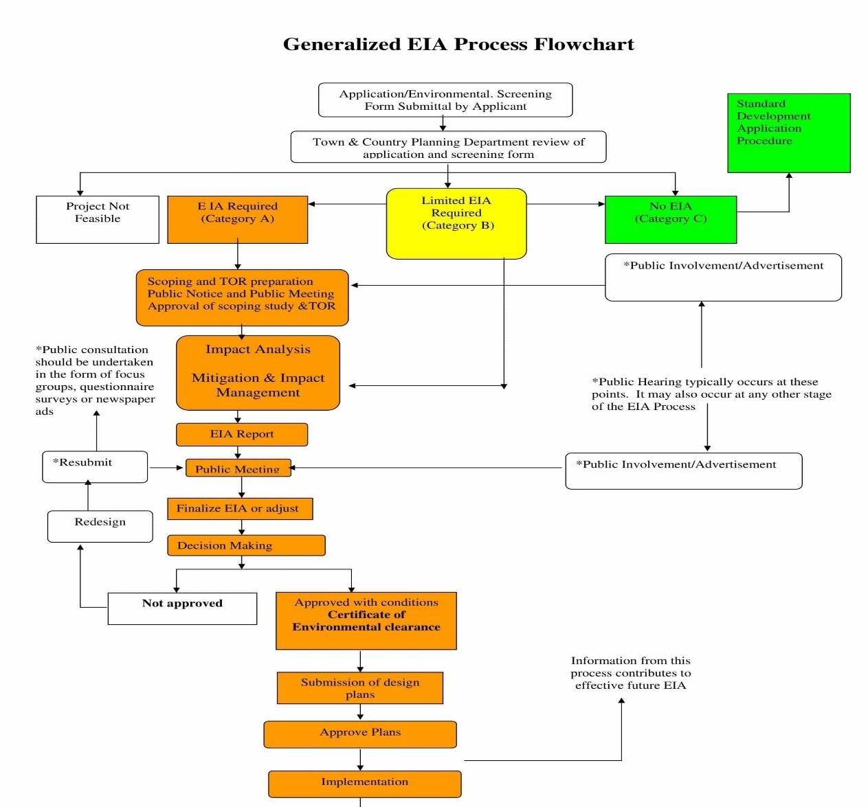

**Advantages of EIA**

* EIA links environment with development for environmentally safe and sustainable development.
* EIA provides a cost-effective method to eliminate or minimize the adverse impact of developmental projects.
* EIA enables the decision makers to analyse the effect of developmental activities on the environment well before the developmental project is implemented.
* EIA encourages the adaptation of mitigation strategies in the developmental plan.
* EIA makes sure that the developmental plan is environmentally sound and within the limits of the capacity of assimilation and regeneration of the ecosystem.

**Disadvantages of EIA**

* **Applicability:** There are several projects with significant environmental impacts that are exempted from the notification either because they are not listed in schedule I, or their investments are less than what is provided for in the notification.
* **Composition of expert committees and standards:** It has been found that the team formed for conducting EIA studies is lacking the expertise in various fields such as environmentalists, wildlife experts, Anthropologists and Social Scientists.
* **Public hearing:**
  + Public comments are not considered at an early stage, which often leads to conflict at a later stage of project clearance.
  + A number of projects with significant environmental and social impacts have been excluded from the mandatory public hearing process.
  + The data collectors do not pay respect to the indigenous knowledge of local people.
* **Quality of EIA:** One of the biggest concerns with the environmental clearance process is related to the quality of EIA report that are being carried out.
* **Lack of Credibility:**
  + There are so many cases of fraudulent EIA studies where erroneous data has been used, same facts used for two totally different places etc. Often, and more so for strategic industries such as nuclear energy projects, the EMPs are kept confidential for political and administrative reasons.
  + Details regarding the effectiveness and implementation of mitigation measures are often not provided.
  + Emergency preparedness plans are not discussed in sufficient details and the information not disseminated to the communities.